Сущности базы данных

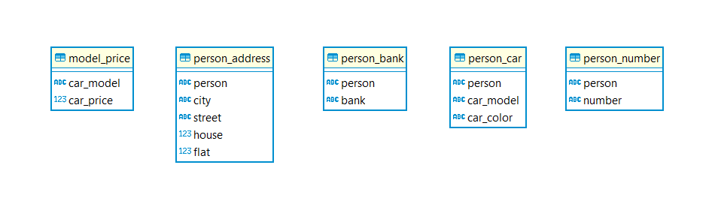

1. Создание

|  |  |
| --- | --- |
| **domains**  person, number = string.  city, street = string.  house, flat = unsigned.  address = address(city, street, house, flat).  car_model, car_color, bank = string.  car_price, bank_sum = unsigned. |  |
| **predicates**  person_number(person, number). | **create table** person_number (  person text,  number text  ); |
| person_car(person, car_model, car_color). | **create table** person_car (  person text,  car_model text,  car_color text  ); |
| model_price(car_model, car_price). | **create table** model_price (  car_model text,  car_price integer  ); |
| person_bank(person, bank). | **create table** person_bank (  person text,  bank text  ); |
| person_address(person, address). | **create table** person_address (  person text,  city text,  street text,  house integer,  flat integer  ); |
| number_car(number, person, car_model, car_price).  person_city_street_bank_number(person, city, street, bank, number).  car_person_city_number_bank(car_model, car_color, person, city, number, bank). |  |

1. Заполнение

|  |  |
| --- | --- |
| **clauses**  person_number("Klimov", "89124214959").  person_number("Ivanov", "89424412959").  person_number("Klimov", "89414215521").  person_number("Petrov", "89412451252"). | **insert into** person_number(person, number) **values**('Klimov', '89124214959');  **insert into** person_number(person, number) **values**('Ivanov', '89424412959');  **insert into** person_number(person, number) **values**('Klimov', '89414215521');  **insert into** person_number(person, number) **values**('Petrov', '89412451252'); |
| person_car("Ivanov", "Audi", "Black").  person_car("Klimov", "Nissan", "White").  person_car("Petrov", "BMW", "Green").  person_car("Klimov", "BMW", "Green"). | **insert into** person_car(person, car_model, car_color) **values**('Ivanov', 'Audi', 'Black');  **insert into** person_car(person, car_model, car_color) **values**('Klimov', 'Nissan', 'White');  **insert into** person_car(person, car_model, car_color) **values**('Petrov', 'BMW', 'Green');  **insert into** person_car(person, car_model, car_color) **values**('Klimov', 'BMW', 'Green'); |
| model_price("BMW", 500000).  model_price("Audi", 400000).  model_price("Nissan", 200000). | **insert into** model_price(car_model, car_price) **values**('BMW', 500000);  **insert into** model_price(car_model, car_price) **values**('Audi', 400000);  **insert into** model_price(car_model, car_price) **values**('Nissan', 200000); |
| person_bank("Petrov", "Sber").  person_bank("Klimov", "Tinkoff").  person_bank("Klimov", "Alpha").  person_bank("Ivanov", "Sber"). | **insert into** person_bank(person, bank) **values**('Petrov', 'Sber');  **insert into** person_bank(person, bank) **values**('Klimov', 'Tinkoff');  **insert into** person_bank(person, bank) **values**('Klimov', 'Alpha');  **insert into** person_bank(person, bank) **values**('Ivanov', 'Sber'); |
| person_address("Klimov", address("Moscow", "Street_1", 1, 12)).  person_address("Ivanov", address("Moscow", "Street_2", 2, 32)).  person_address("Petrov", address("St.Peterburg", "Street_3", 3, 42)).  person_address("Klimov", address("St. Peterburg", "Street_4", 4, 52)). | **insert into** person_address(person, city, street, house, flat) **values**('Klimov', 'Moscow', 'Street_1', 1, 12);  **insert into** person_address(person, city, street, house, flat) **values**('Ivanov', 'Moscow', 'Street_2', 2, 32);  **insert into** person_address(person, city, street, house, flat) **values**('Petrov', 'St.Peterburg', 'Street_3', 3, 42);  **insert into** person_address(person, city, street, house, flat) **values**('Klimov', 'St.Peterburg', 'Street_4', 4, 52); |
| number_car(Number, Person, Car_model, Car_price) :- person_number(Person, Number), person_car(Person, Car_model, _), model_price(Car_model, Car_price).  person_city_street_bank_number(Person, City, Street, Bank, Number) :- person_address(Person, address(City, Street, _, _)), person_bank(Person, Bank), person_number(Person, Number).  car_person_city_number_bank(Model, Color, Person, City, Number, Bank) :-  person_car(Person, Model, Color), person_address(Person, address(City, _, _, _)), person_number(Person, Number), person_bank(Person, Bank). |  |

1. Поиск

|  |  |
| --- | --- |
| **goal**  number_car("89124214959", Person, Model, Price). | **select** pn.person, pc.car_model, mp.car_price  **from** (**select** * **from** person_number  **where** **number** = '89124214959') pn  **join** person_car pc **on** pn.person = pc.person  **join** model_price mp **on** pc.car_model = mp.car_model; |
| number_car("89424412959", _, Model, _). | **select** pc.car_model  **from** (**select** * **from** person_number  **where** **number** = '89424412959') pn  **join** person_car pc **on** pn.person = pc.person; |
| person_city_street_bank_number("Klimov", "Moscow", Street, Bank, Number). | **select** pa.street, pb.bank, pn.number  **from** (**select** person, street  **from** person_address **where** person = 'Klimov' **and** city = 'Moscow') pa  **join** person_bank pb **on** pa.person = pb.person  **join** person_number pn **on** pa.person = pn.person; |
| car_person_city_number_bank("BMW", "Green", Person, City, Number, Bank). | **select** pc.person, pa.city, pn.number, pb.bank  **from** (**select** person **from** person_car **where** car_model = 'BMW' **and** car_color = 'Green') pc  **join** person_address pa **on** pc.person = pa.person  **join** person_number pn **on** pc.person = pn.person  **join** person_bank pb **on** pc.person = pb.person; |
| car_person_city_number_bank("Audi", "Black", Person, City, Number, Bank). | **select** pc.person, pa.city, pn.number, pb.bank  **from** (**select** person **from** person_car **where** car_model = 'Audi' **and** car_color = 'Black') pc  **join** person_address pa **on** pc.person = pa.person  **join** person_number pn **on** pc.person = pn.person  **join** person_bank pb **on** pc.person = pb.person; |
| car_person_city_number_bank("BMW", "White", Person, City, Number, Bank). | **select** pc.person, pa.city, pn.number, pb.bank  **from** (**select** person **from** person_car **where** car_model = 'BMW' **and** car_color = 'White') pc  **join** person_address pa **on** pc.person = pa.person  **join** person_number pn **on** pc.person = pn.person  **join** person_bank pb **on** pc.person = pb.person; |